**2.5 I can complete development tasks in a timely manner**

I have been able to complete a number of allotted tasks or units in a timely manner. For those which I have not during this project are for the following reasons.

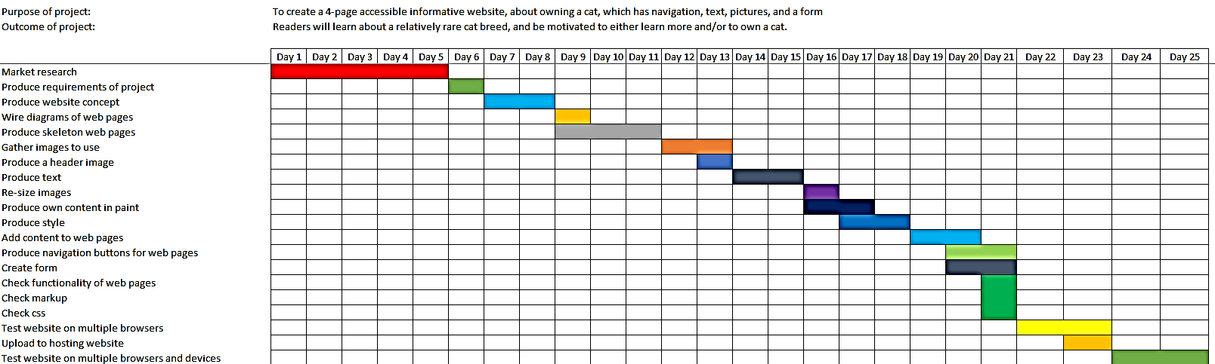

In this Gantt chart, time I needed more time than I allowed for each task, and tasks often overlapped.

**Difficulty of the work**

Much of the content and type of work that we needed to produce was previously completely unknown to me. Whether it’s using Visual Code, creating a website, exploring GIMP, or even drawing a wire diagram. All these are things I’d never done before, so although I enjoyed the fact I have been learning much, it has meant completing tasks but not in a timely manner.

**Other priorities**

Other things that have come up, both in and out of my paid work, have had an affect on how quickly I have completed a task or how much time I had to commit to it. At the start of the course I was also on another course but I’ve had to postpone that because this course demanded so much of my time. There have been times when I or my partner have been ill, or I’ve had to stay back at work, or we’ve had trouble with our cars which has needed our time to fix, etc. Work have accommodated the course by ensuring I finish on time, but that has mean that I’ve had to start very early at work every day, during which time I naturally cannot commit to the course.

**Misaligned expectations**

Given my experience on other level 2 courses, from the same provider and others, and from the description of the course, I did not anticipate so much work or the intensity of that work.

**Equipment/ hardware**

There have been a few times when I lacked the technology to work on the course, either from being away from my computer or my computer having technical problems such as the internet dropping out.